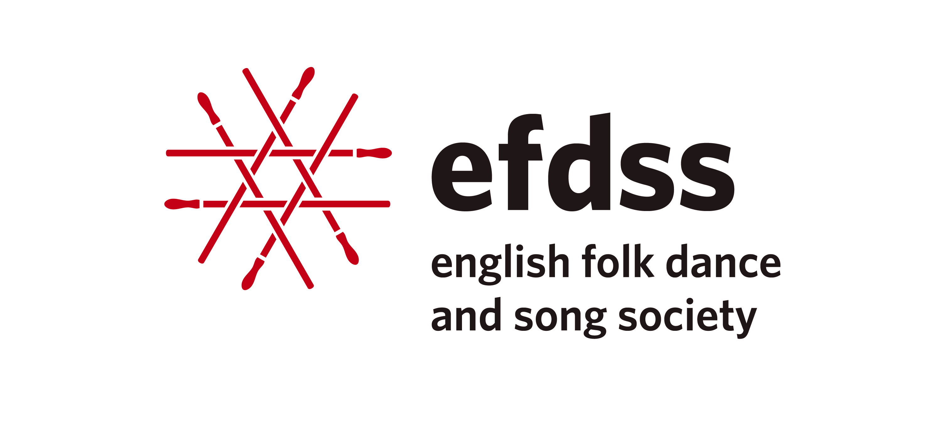
Creative Artist Residency 2015-16
Application Form

Lead Applicant’s Details
Name of artist(s)
Contact address
Postcode
Telephone
Email
Artist(s) website/social media links

Proposal
Please outline the project you would like to work on (300 words max)
Please list and give a brief CV of the artists involved in the residency
How would an EFDSS residency benefit your development? (150 words max)

What are the benefits of the residency for the wider English Folk Community?
(200 words max)
What are the potential future developments for the results of the residency?
(200 words max)
Draft budget and timetable
Number of artists involved:
Suggested dates & duration:
Travel costs:

Accommodation costs:

Fees:
Other expenses:

Dates and submission details
Deadline for completed applications Friday 29th May 2015
All residencies to be taken between September 2015 and March 2016
Decisions to be made public late June/early July 2015
Completed applications should be returned to Neil Pearson (Artist Development and Programming Manager)
Email: neil@efdss.org
Post: Cecil Sharp House, 2 Regent’s Park Road, London, NW1 7AY

