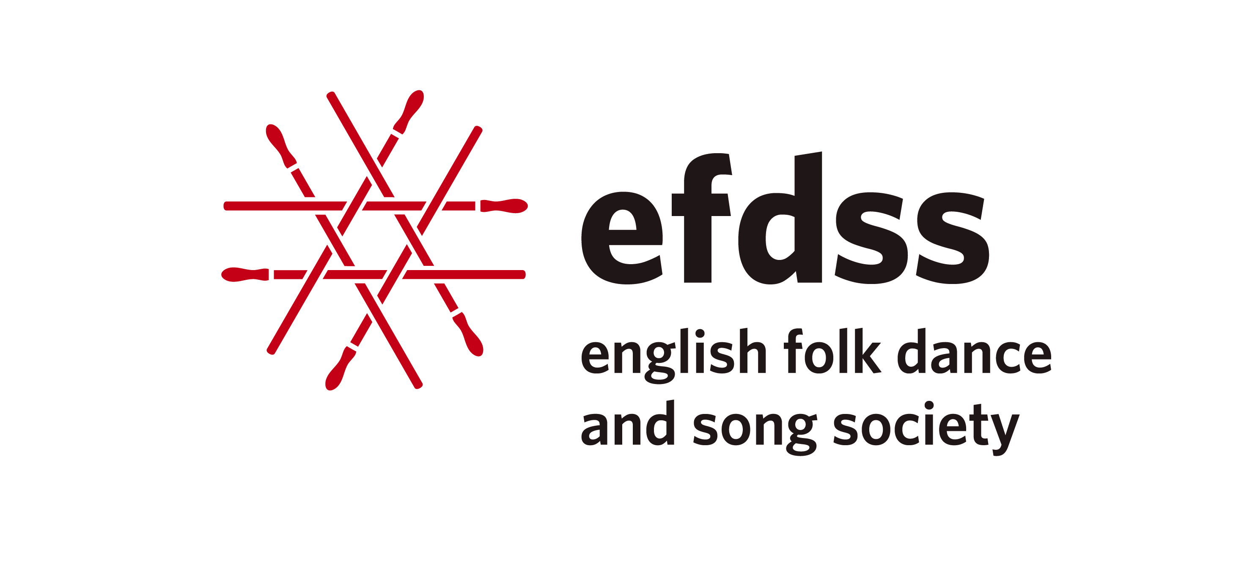

**CONNECTIONS**

***exploring the tangible and intangible heritage of England***

**Musicians in Museums residencies**

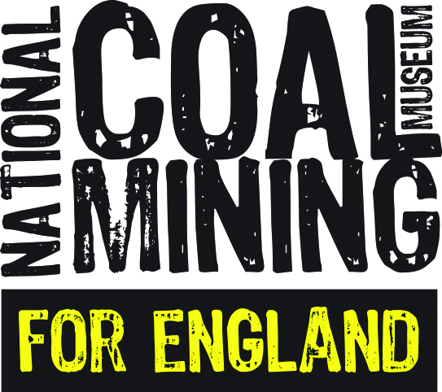 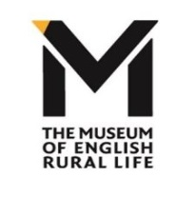

The English Folk Dance and Song Society in partnership with the National Coal Mining Museum for England, the National Maritime Museum, and the Museum of English Rural Life, and funded by Help Musicians, are offering a creative opportunity for folk musicians to become artists-in-residence at one of the aforementioned museums over a 12 month period.

The programme is aimed at folk music artists working in the English folk idiom with a strong knowledge of traditional English music material (songs/tunes), proven creative excellence that draws upon English traditional material, and with proven teaching skills.

The aim of the programme is to

* offer a creative opportunity for a professional musician working in the English folk idiom (song/instrumental) to draw upon the collection(s) and themes of the museum to inspire a new piece of music;
* for the artist to develop their communication skills through leading workshops with eg young people, schools, adult groups, which will illuminate their creative practice and process and providing a different way to present the museum’s collections.
* bring together tangible and intangible heritage through the creation of a new musical work and associated education projects and develop new audiences for both.

One artist per museum will be appointed and offered a bursary of £5,000 to provide funding for:-

* research and creative time over a year’s period including an agreed number of contact days with the host museum;
* devise and deliver 10 days of learning programme;
* devised and write learning materials to accompany the learning programme to be used be used by EFDSS and the host museum;
* create 15-20 minutes of new music (song and/or instrumental)
* 1 public performance at the end of the residency at the host museum. A further performance at Cecil Sharp House may also be arranged; an additional performance fee would be paid for this.

There is also a travel/accommodation allowance of £500

The museum may arrange with the artist, and pay for directly, additional teaching days within reason.

The Artist will work with the museum over a period of 12 months, spending sufficient time with the museum staff and collections to fully understand the materials and themes of the host museum. The exact schedule for the year is flexible and aims to enable artists to continue to undertake a level of other work eg touring, recording etc, but a commitment to this project is crucial. The Artist will be supported by the Artists Development Team at EFDSS and is also encouraged to use the Vaughan William Memorial Library (EFDSS’s Library) for research (in person/online).

**THE RESIDENCIES**

**National Coal Mining Museum for England, Wakefield, Yorkshire**

The National Coal Mining Museum for England is based at the site of [Caphouse Colliery](https://en.wikipedia.org/wiki/Caphouse_Colliery" \o "Caphouse Colliery) in [Overton](https://en.wikipedia.org/wiki/Overton,_Wakefield), near [Wakefield](https://en.wikipedia.org/wiki/Wakefield), [West Yorkshire](https://en.wikipedia.org/wiki/West_Yorkshire). It opened in 1988 as the Yorkshire Mining Museum and was granted national status in 1995. The museum offers guided underground tours where visitors can experience the conditions miners worked in and see the tools and machines they used as the industry and the mine developed through the years. Above ground there is a visitor centre which houses exhibitions on the [social](https://en.wikipedia.org/wiki/Social_history) and [industrial history](https://en.wikipedia.org/wiki/Industrial_history) of the mines. The extensive library and archive contains issues of "Coal News" and details of collieries throughout England. Other features include the pit head baths, steam winding house, boiler house and coal screening plant. It is possible to see former working [pit ponies](https://en.wikipedia.org/wiki/Pit_ponies), ride the [paddy train](https://en.wikipedia.org/wiki/Paddy_train) and follow the [nature trail](https://en.wikipedia.org/wiki/Nature_trail) near to Hope Pit and water filtration tanks.

<https://www.ncm.org.uk/> | <https://twitter.com/ncmme> | <https://www.facebook.com/NCMME/>

**Period**

Late September/early October 2017 for 12 months

**Theme/Collection**

The Artist will work alongside the exhibition team to identify the ‘unseen’ collections of the museum, in particular the art/photography collection and the Library collection.

**Outreach**

The Artist will work with some/all of the following:

* Cultural Olympiad project – workshops to celebrate culture and creativity in the mining industry (families - autumn half term. 2017)
* young musicians (11+) who attend Wakefield Music Hub music centres
* young musicians from local secondary schools
* museum volunteers
* family audience – over summer holiday 2018

**National Maritime Museum, Greenwich**

The National Maritime Museum (NMM) in [Greenwich](https://en.wikipedia.org/wiki/Greenwich), London, is the leading [maritime museum](https://en.wikipedia.org/wiki/Maritime_museum) of the United Kingdom and may be the largest museum of its kind in the world. The historic buildings form part of the [Maritime Greenwich](https://en.wikipedia.org/wiki/Maritime_Greenwich) [World Heritage Site](https://en.wikipedia.org/wiki/World_Heritage_Site), and it also incorporates the [Royal Observatory](https://en.wikipedia.org/wiki/Royal_Observatory,_Greenwich) and 17th-century [Queen's House](https://en.wikipedia.org/wiki/Queen%27s_House). In 2012, [Her Majesty the Queen](https://en.wikipedia.org/wiki/Queen_Elizabeth_II) formally approved Royal Museums Greenwich as the new overall title for the National Maritime Museum, Queen’s House, the Royal Observatory, Greenwich, and the [*Cutty Sark*](https://en.wikipedia.org/wiki/Cutty_Sark).

<http://www.rmg.co.uk/national-maritime-museum> | <https://twitter.com/nmmgreenwich> | <https://www.facebook.com/nationalmaritimemuseum>

Period - January 2018 for 12 months

*Full details will be advertised in September*

**Museum of English Rural Life, Reading**

The Museum of English Rural Life is owned and managed by the University of Reading. It was established by academics in the Department of Agriculture in 1951 to capture and record the rapidly changing countryside following World War II. In 2005 the Museum moved to its current premises in St Andrew’s Hall, a building designed by Sir Alfred Waterhouse in 1880 for local businessman Alfred Palmer of the Huntley & Palmer biscuit company. The Museum was awarded £1.8million from the Heritage Lottery Fund (HLF) in 2014 for the redevelopment of the galleries, reopening in October 2016. The new Museum uses its diverse and surprising collection to explore how the skills and experiences of farmers and craftspeople, past and present, can help shape our lives now and into the future. The Museum has worked alongside rural people, local communities and specialist researchers to create displays and activities that engage with important debates about the future of food and the ongoing relevance of the countryside to all our lives.

<https://www.reading.ac.uk/TheMERL> | <https://twitter.com/TheMERL>| <https://www.facebook.com/MuseumofEnglishRuralLife/>

Period – January/February 2018 for 12 months

*Full details will be advertised in September*

**English Folk Dance and Song Society**

The English Folk Dance and Song Society (EFDSS) was established in 1932 by the merger of the Folk-Song Society, founded in 1898, and the English Folk Dance Society, founded by Cecil Sharp in 1911. As the national development organisation for the folk arts, EFDSS aims to place the traditional arts of England at the heart of our cultural life - preserving, protecting, disseminating and promoting English traditional folk arts. Since its beginnings EFDSS has been supporting artists and practitioners, engaging people in folk arts activities, and raising the profile of this art form. This is currently achieved through programmes of performance, participation and education at EFDSS’ London venue, Cecil Sharp House, and with partners in the UK and overseas. EFDSS is increasingly developing projects to support the creative development of artists and expanding their opportunities for performance.

[www.efdss.org](http://www.edfdss.org) | [www.twitter.com/TheEFDSS](http://www.twitter.com/TheEFDSS) | [www.facebook.com/theefdss](http://www.facebook.com/theefdss)

**How to Apply**

**Applications are now been accepted for the residency with the National Coal Mining Museum, closing date for which is Monday 31 July 2017. Interviews will be on 12/13 September at the NCMM.**

Applications for the residencies at National Maritime Museum and Museum of English Rural Life will be advertised in September.

This project is supported by funds from: EFDSS is a National Portfolio Organisation of:

 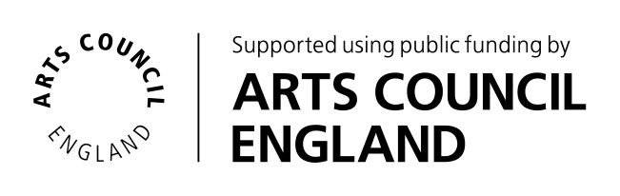





**APPLICATION FOR *CONNECTIONS -* MUSIC IN MUSEUMS RESIDENCY PROGRAMME**

**WITH THE NATIONAL COAL MINING MUSEUM for ENGLAND**

|  |
| --- |
| **Name of artist** |
| **Contact address** |
| **Postcode** |
| **Telephone / Mobile** |
| **Email** |
| **Website/social media links** |

**Please provide an outline of your professional music activities eg performance/ recording/composing**

|  |
| --- |
|  |

**Professional career information continued.**

|  |
| --- |
|  |

**Please provide an outline of your professional teaching experience including age groups and levels of teaching eg Key Stages, Higher Education students, beginners, adults, young people etc…**

|  |
| --- |
|  |

**Please outline why you are interested in this residency with the National Coal Mining Museum and what you would bring to the residency.**

|  |
| --- |
|  |

**Please describe how such a residency could develop your skills and career.**

|  |
| --- |
|  |

Applicants are welcome to have an informal conversation prior to the submission of their application with Katy Spicer, Chief Executive and Artistic Director, EFDSS ([katy@efdss.org](mailto:katy@efdss.org) / 020 7241 8957) or Jayne Ambrose, Education Officer, NCMM ([jayne@ncm.org.uk](mailto:jayne@ncm.org.uk) / 01924 848806 on Tuesdays, Wednesdays or Thursdays ).

**Completed applications should be emailed to Zoe Nicol, Artistic Programme Co-ordinator at** [**zoe@efdss.org**](mailto:zoe@efdss.org) **by midnight on Monday 31 July 2017**

This project is supported by funds from: EFDSS is a National Portfolio Organisation of:

 